Overview of Project Two:
I completed this project for Grazioso Salvare, who is an international rescue animal training organization. The purpose of the dashboard is to allow users to access animal shelter data stored in MongoDB and identify dogs that meet specific search-and-rescue training criteria.

The dashboard provides an interactive interface that allows users to:
- View all available shelter animals
- Filter animals by rescue category
- Visualize animal data through charts
- View animal locations on an interactive map
- Reset filters to return to the full dataset

The application follows the Model-View-Controller (MVC) design pattern:
- Model: MongoDB database
- View: Dash dashboard interface
- Controller: Python callbacks and CRUD module

Required Functionality:
The dashboard includes the following functionality:
- Interactive Data Table
- Displays all animal shelter records
- Supports sorting and filtering
- Supports row selection
- Dynamically updates based on rescue type filters

Rescue Filters
The dashboard provides filtering options for:
- Water Rescue
- Mountain/Wilderness Rescue
- Disaster/Individual Tracking
- Reset (all records)
Each of these filters execute a MongoDB query and updates all the dashboard components.

Data Visualization
A pie chart displays breed distribution for the currently filtered dataset.

Geolocation Map
An interactive map displays the location of the selected animal record and updates dynamically when the data table changes.

Branding and Identification
In the dashboard, I have included the Grazioso Salvare logo and my name, Ava Lindgren, as the student identifier.

Screenshots
Startup Page:
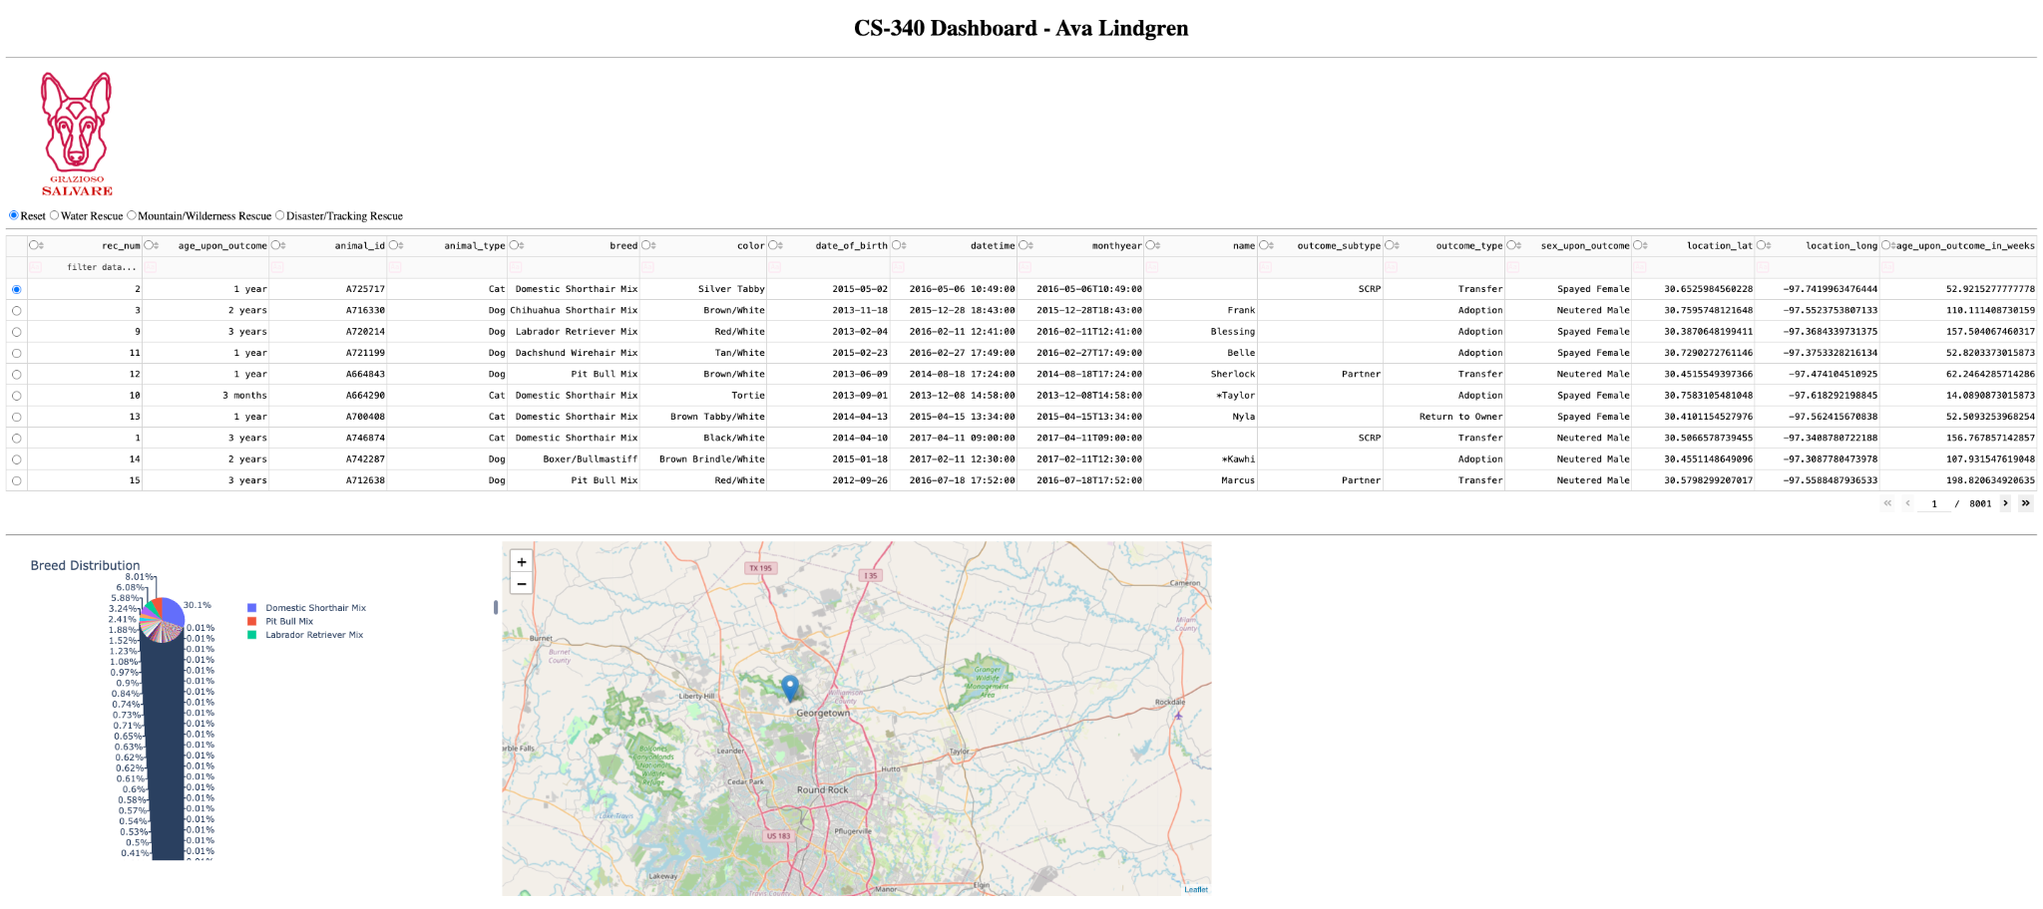
The dashboard displays rescue filter controls, complete animal shelter dataset, breed distribution chart, and a geolocation map

Water Rescue:
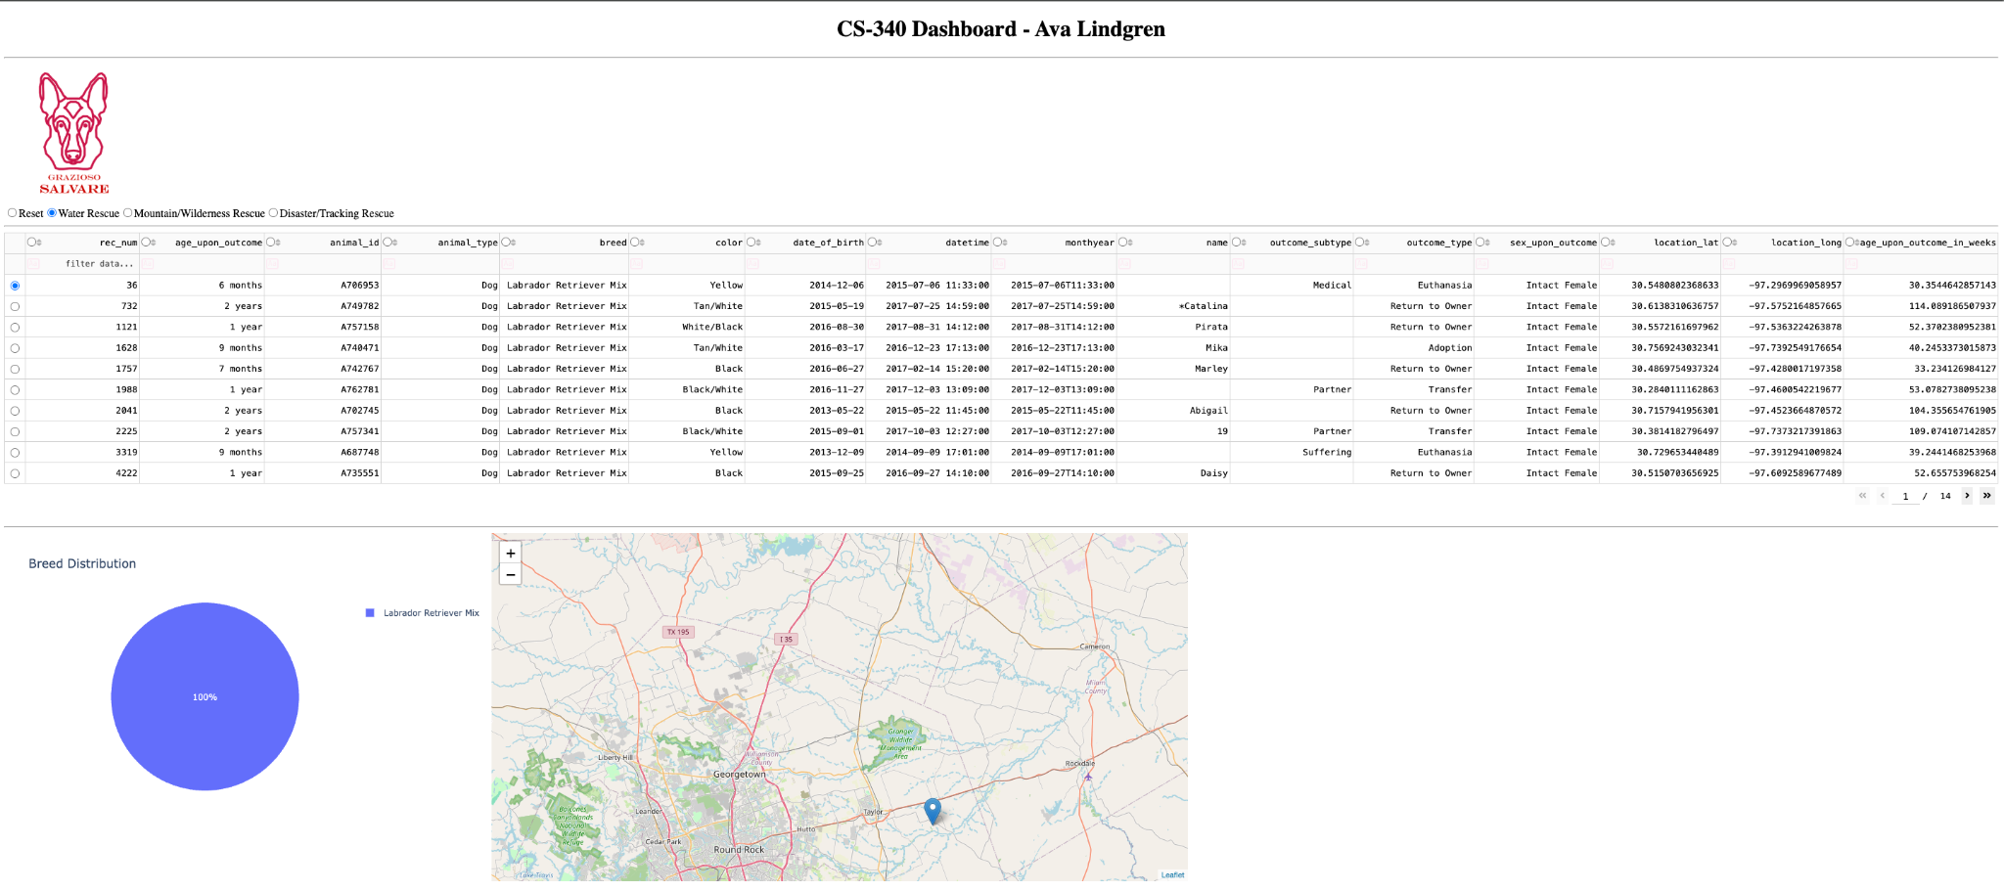
The above screenshot demonstrates successful filtering of dogs that meet Water Rescue criteria

Mountain/ Wilderness Rescue:
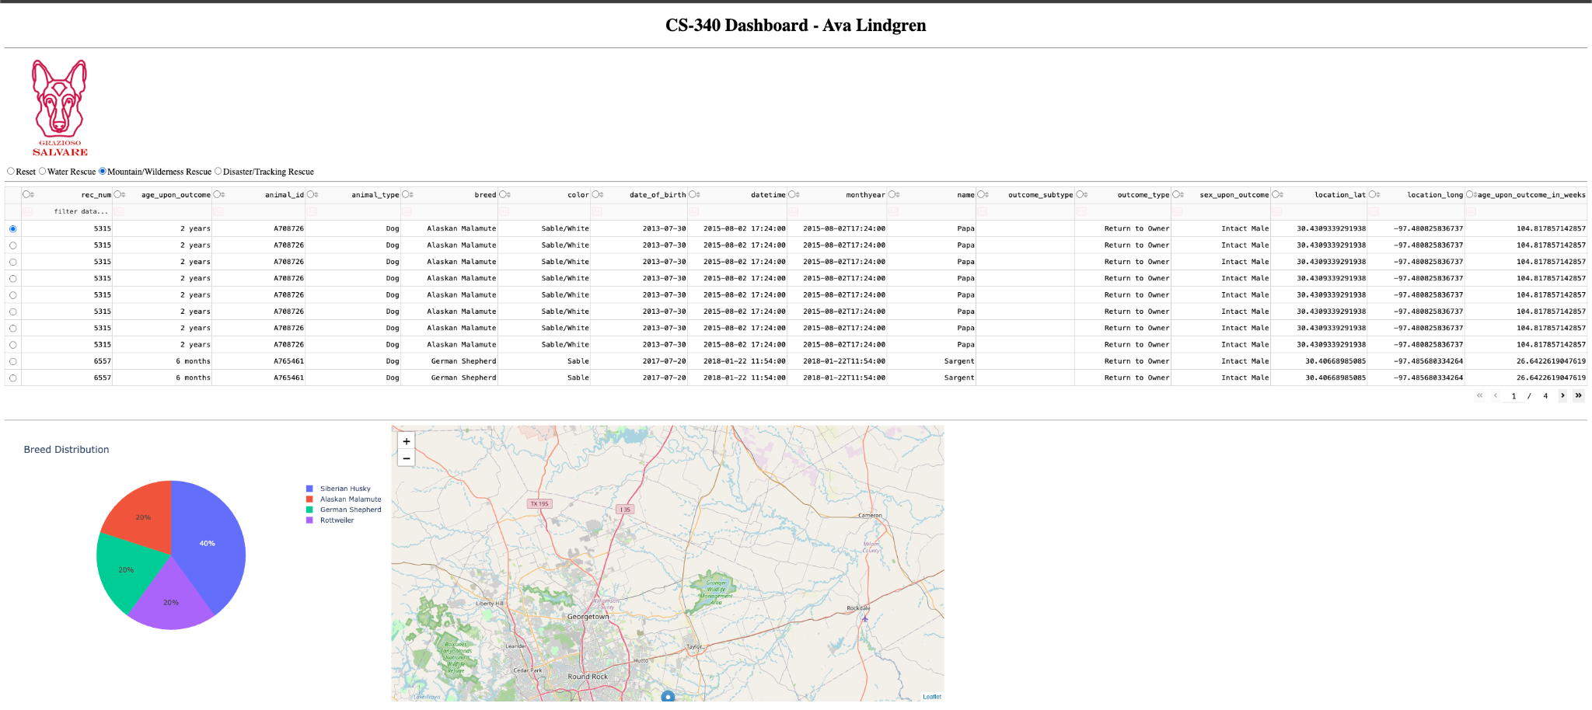
The above screenshot demonstrates successful filtering of dogs that meet Mountain/Wilderness Rescue criteria

Disaster/ Tracking Rescue:
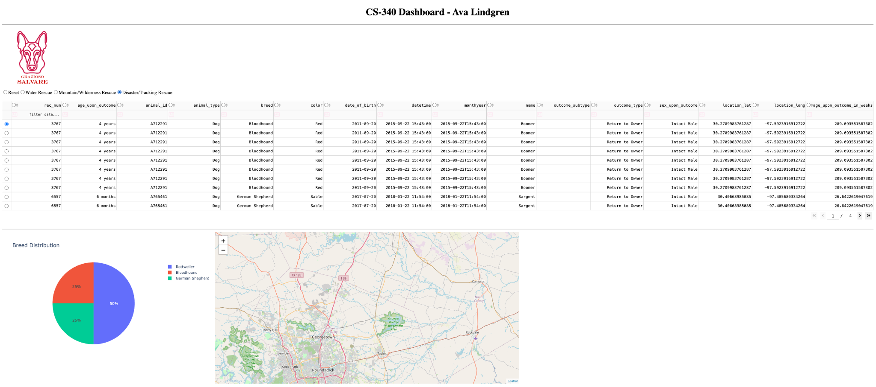
The above screenshot demonstrates successful filtering of dogs that meet Disaster/Individual Tracking criteria

Reset Function:
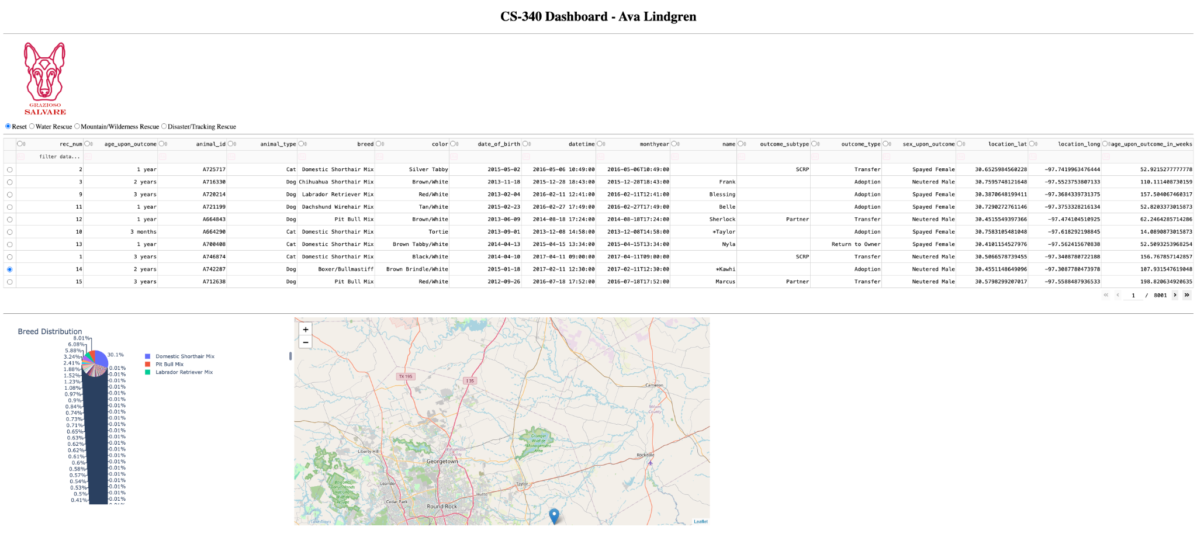
The above screenshot demonstrates restoration of the complete dataset and all dashboard widgets

Tools and Technologies Used
Python was used as the primary programming language because it provides extensive support for data analysis, database connectivity, and web application development.

MongoDB was used as the model component of the MVC architecture.
MongoDB offers flexible document-based storage, JSON-style data structure, efficient querying and filtering, easy integration with Python through PyMongo, and scalability for large datasets.
MongoDB also allows shelter records to be stored as documents and retrieved quickly using custom queries.

PyMongo was used to connect Python applications to MongoDB.
PyMongo enabled database connectivity, CRUD operations, query execution, and data retrieval for dashboard visualization.

Dash was used to create the dashboard interface.
Dash provides interactive web applications using Python, reactive callbacks, integration with Plotly visualizations, and support for data tables and mapping components.
Dash also serves as both the View and Controller portions of the MVC architecture.

Plotly Express was used to generate the breed distribution pie chart.
Benefits of Plotly Express include interactive visualizations, simple integration with Dash, and dynamic updates based on filtered data.

Dash Leaflet was used to create the geolocation map component.
Benefits of Dash Leaflet include their interactive maps, marker placement based on selected records, and easy integration with Dash applications.

Pandas was used for data manipulation, conversion of MongoDB query results into DataFrames, and preparing data for visualizations.

Project Steps
- Create MongoDB Database
  - The Austin Animal Center dataset was imported into MongoDB.
- Develop CRUD Module
  - A Python CRUD module was developed to support Create, Read, Update, Delete operations against MongoDB.
- Connect Dashboard to Database
  - The dashboard was connected to MongoDB using the custom CRUD module.
- Create Data Table
  - A Dash DataTable was created to display all shelter records.
- Implement Rescue Filters
  - MongoDB queries were created for water rescue, mountain/wilderness rescue, and disaster/individual tracking.
- Create Interactive Dashboard Components
  - Callbacks were implemented to update the data table, pie chart, and the map based on selected filters.
- Test and Deploy
  - The dashboard was tested to verify database connectivity, the correct query execution, interactive filtering, chart updates, and map updates. Screenshots were taken as evidence of functionality for each.

Challenges
- Several callback errors occurred during development due to missing values being passed to dashboard components during initialization, but I was able to add validation checks for None values before processing data.
- The DataTable initially generated errors related to selected columns and row selection, but I added appropriate DataTable properties and callback handling.
- Constructing rescue-specific MongoDB filters required careful matching of breed, age, and sex criteria, but I was able to test queries individually against the database and verified returned records.
- Displaying map markers required selecting valid coordinates from the dataset and ensuring updates occurred correctly when rows were selected, so I added callback logic to handle row selections and map updates dynamically.

